**PIZZA SALES SQL QUERIES**

1. **KPI’S**
2. Total Revenue

SELECT ROUND(SUM(total_price)::DECIMAL,2) AS Total_Revenue

FROM pizza_sales

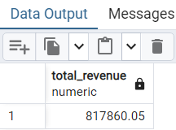

1. Average Order Value

SELECT ROUND((SUM(total_price)/COUNT(DISTINCT order_id))::DECIMAL,2) AS Average_Order_Value

FROM pizza_sales

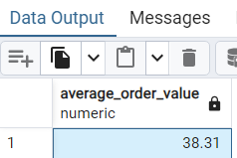

1. Total Pizzas Sold

SELECT SUM(quantity) AS Total_Pizzas_Sold FROM pizza_sales

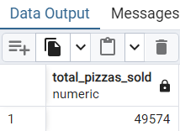

1. Total Orders

SELECT COUNT(DISTINCT order_id) AS Total_Orders FROM pizza_sales

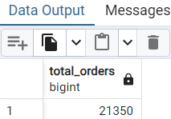

1. Average pizzas per Order

SELECT ROUND((SUM(quantity)/CAST((COUNT(DISTINCT order_id)) AS DECIMAL))::DECIMAL,2) AS Average_pizzas_per_order FROM pizza_sales

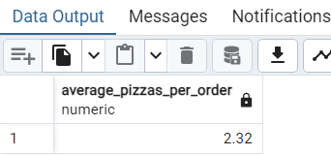

1. **Daily Trend For Orders**

SELECT to_char(order_date,'Day') AS DAY, COUNT(DISTINCT order_id) AS Total_orders

FROM pizza_sales

GROUP BY to_char(order_date,'Day')

ORDER BY total_orders DESC

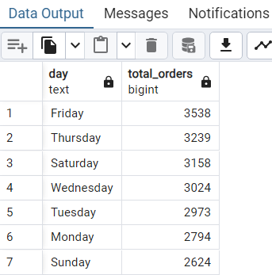

1. **Hourly Trend For Orders**

SELECT EXTRACT(HOUR FROM order_time) AS order_hour , COUNT(DISTINCT order_id) AS Total_orders

FROM pizza_sales

GROUP BY EXTRACT(HOUR FROM order_time)

ORDER BY EXTRACT(HOUR FROM order_time)

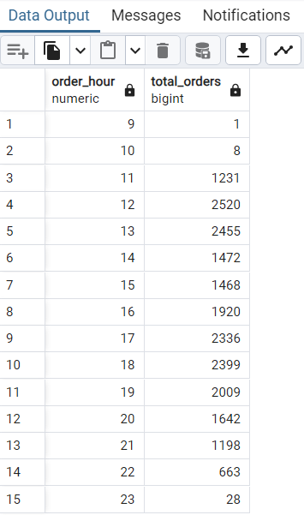

1. **Percentage of Sales by PIZZA Category**

SELECT pizza_category,ROUND(SUM(total_price)::DECIMAL,2) AS Total_sales,

ROUND(((SUM(total_price)/(SELECT SUM(total_price) FROM pizza_sales WHERE to_char(order_date,'MM')= '01' ))*100)::DECIMAL,2) AS PCT

FROM pizza_sales

WHERE to_char(order_date,'MM')= '01'

-->This WHERE clause only applies to the external query.

GROUP BY pizza_category

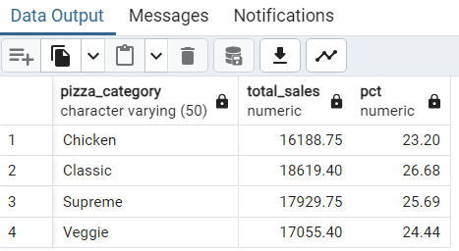

1. **Percentage of Sales by Pizza Size**

SELECT pizza_size,ROUND(SUM(total_price)::DECIMAL,2) AS Total_sales,

ROUND(((SUM(total_price)/(SELECT SUM(total_price) FROM pizza_sales WHERE to_char(order_date,'Q') = '4' ))*100)::DECIMAL,2) AS PCT

FROM pizza_sales

WHERE to_char(order_date,'Q') = '4'

GROUP BY pizza_size

ORDER BY PCT DESC

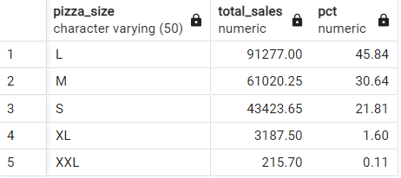

1. **Category Total Pizzas Sold by Pizza**

SELECT pizza_category,SUM(quantity) AS No_of_pizzas_sold

FROM pizza_sales

GROUP BY pizza_category

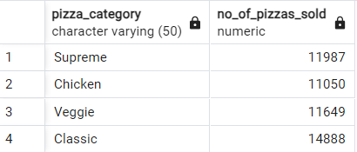

1. **Top 5 Best Sellers by Total Pizzas Sold:**

--> Top 5 best seller pizza (for 1st Month i.e. January)

SELECT pizza_name,SUM(quantity) AS Total_Pizzas_Sold

FROM pizza_sales

WHERE to_char(order_date,'MM') = '01'

GROUP BY pizza_name

ORDER BY SUM(quantity) DESC

LIMIT 5

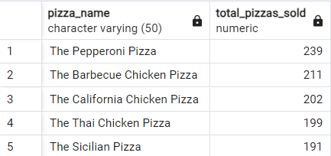

1. **Bottom 5 Worst Sellers by Total Pizzas Sold 🡪 for the month of January**

SELECT pizza_name,SUM(quantity) AS Total_Pizzas_Sold

FROM pizza_sales

WHERE to_char(order_date,'MM') = '01'

GROUP BY pizza_name

ORDER BY SUM(quantity) ASC

LIMIT 5

